Doctor, Doctor!
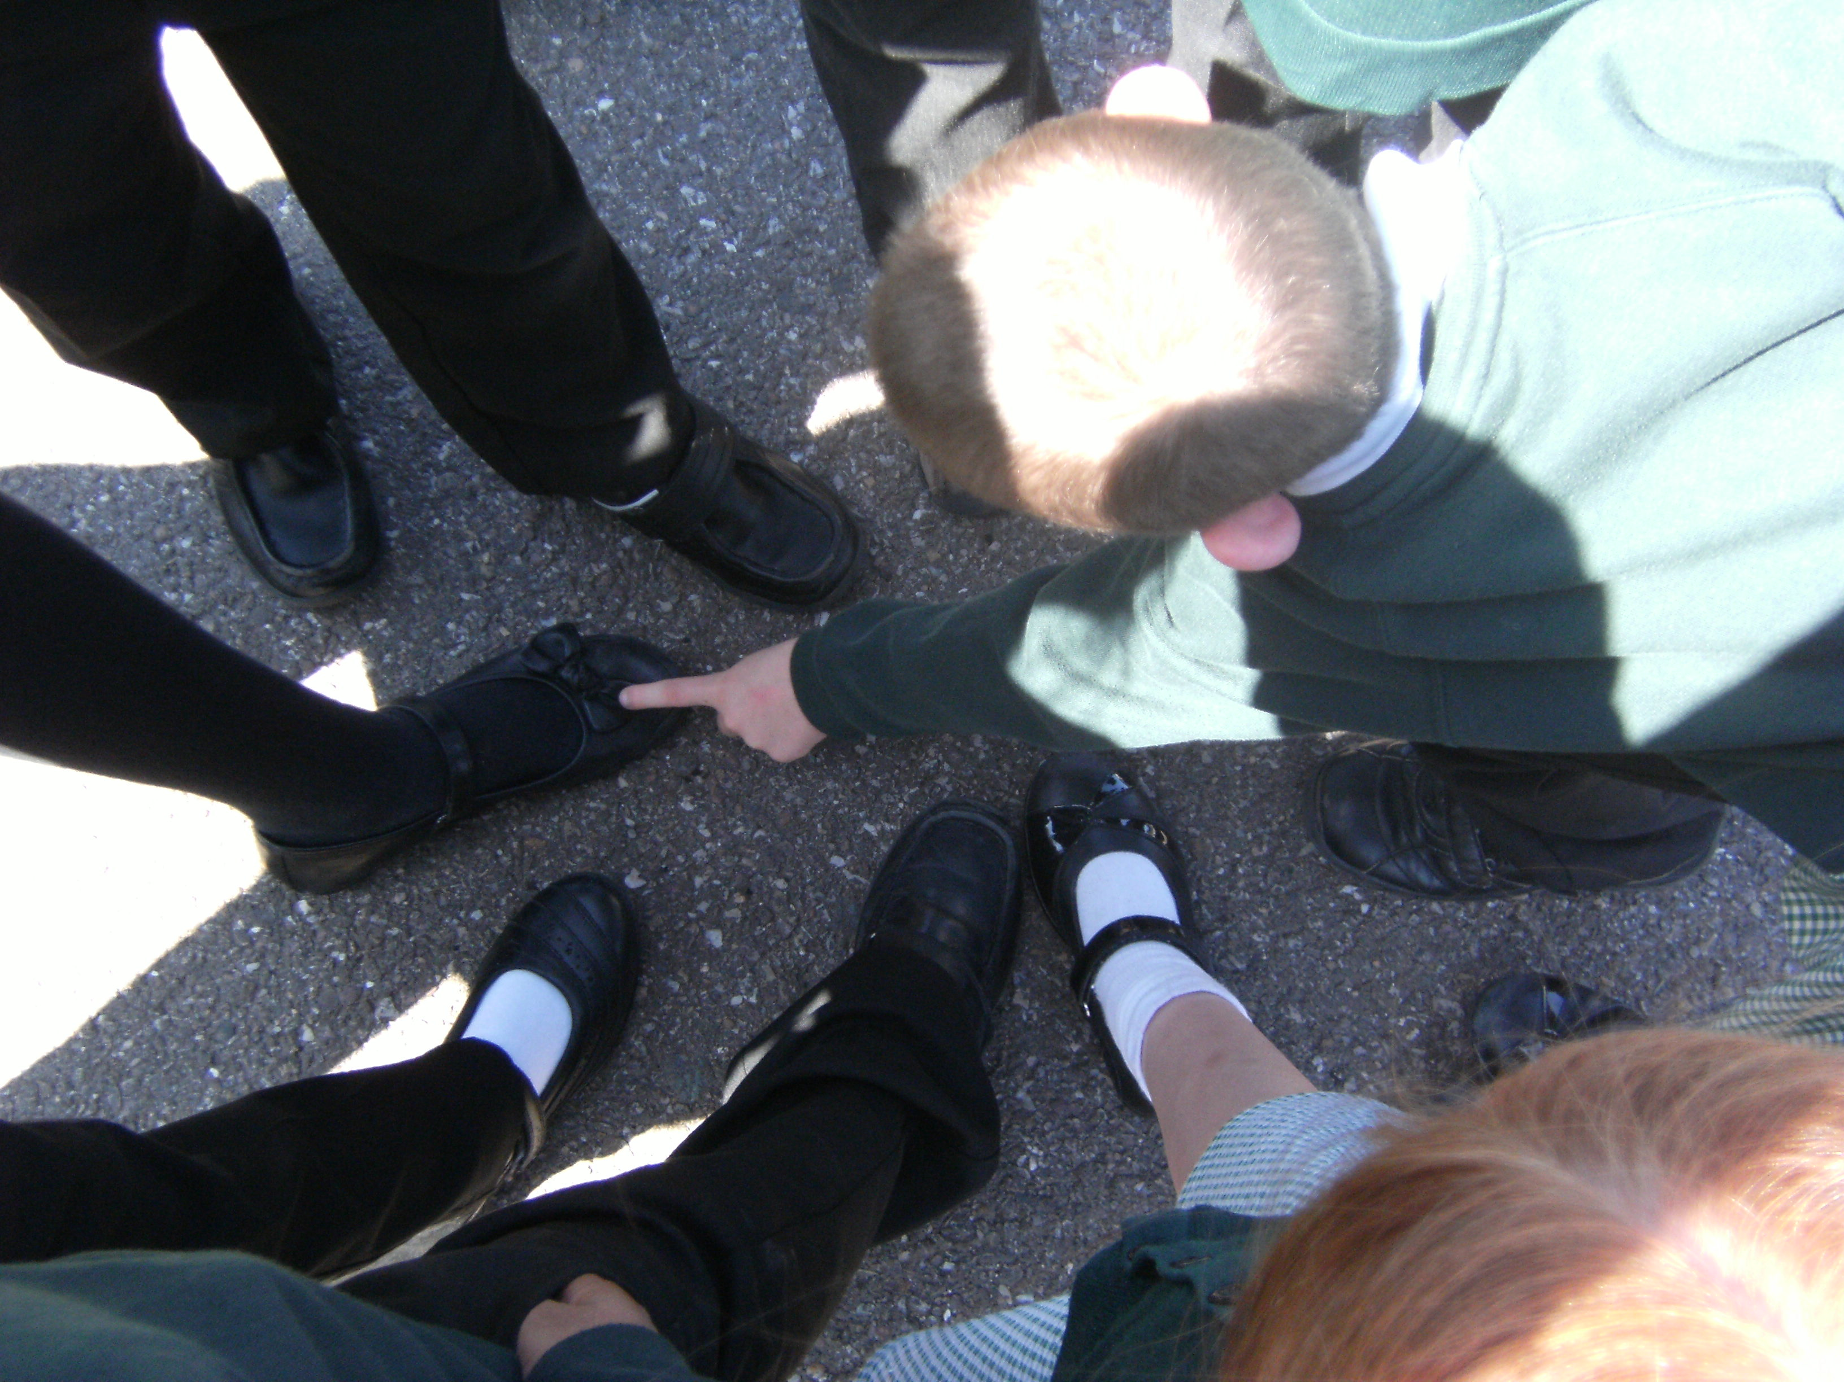
You Will Need
6 or more players

How to Play


- Choose one player to be
Doctor.

- The doctor stands away from the
other players looking the other way.


- The rest of the players hold hands
in a circle facing inwards.

- The circle tangles itself up by going
underneath each others arms or
twisting round
WITHOUT LETTING GO OF HANDS.


- When there is a big tangle the
players call out “Doctor, Doctor!”

- The Doctor runs over and works
out how to untangle everybody.

- When everyone is untangled
choose a new doctor and start again.

